**Problem Statement:**

**1) Integrate Hbase with Hive**

**2) Load Data (Bulk Load) from Hive table to Hbase Table**

**3) Explain the procedures and code implemented with screenshots**.

**STEP 1:-**

Create a table emp in hbase with column family: name:-

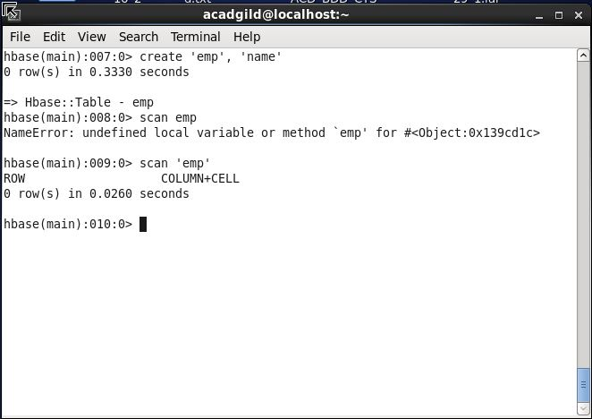

**Step 2:-**

We have created a table in employee and the data is loaded into it as shown below:-

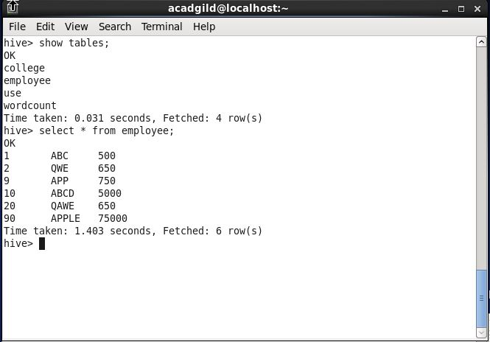

**Step-3:-**

Here we have created an external table in hive_hbase the data is written in the table from hive.

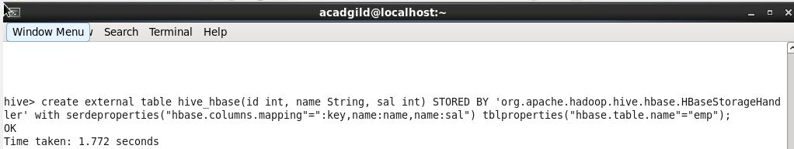

**STEP -4:-**

The data from the hive table employee is written in the hive_hbase table :-

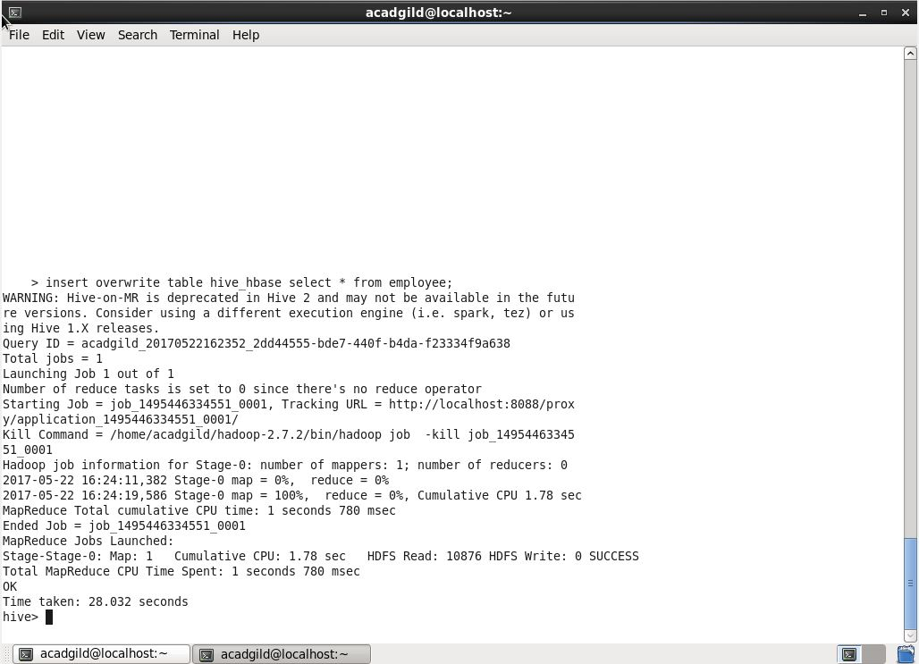

**Step -5:-**

The Hbase table is written with the data from the employee table:-

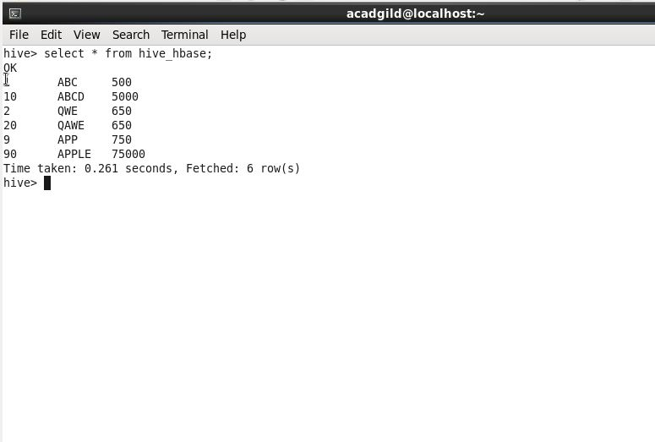

**STEP -6:-**

The data is written into the table we have created in Hbase and the data is over

The expected output is here the data is written in the Hbase table from the hive table :-

